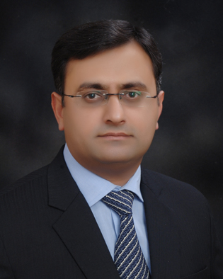
Kashif Baig Profile Summary

Mobile:- +66626987041
Email:- kashif.baig@telenor.com & kashifbaig.kb@gmail.com
Career Objective | To work in a dynamic Telecom environment that challenges my managerial / leadership capabilities to the fullest and expedites my professional & personal growth by allowing me to strengthen my core competence in area of commercial (Customer Experience Management, , Digital & Online / ebusiness and Product Development / Management)
Work Experience  I am a Pakistani national with overall work experience of more than 15 years, all cellular, working with 6 different operators in 4 different markets, which include Asia & Middle East / Africa | Telenor Group (Present)  - Director Customer Centricity (Asia)  Telenor-Bangladesh-Grameenphone (2012 / June 14)  - Head of Customer Experience & Digital - Social Medi  Telenor-Pakistan (2010/11)  - Sr. Manager User Experience, Products & International Roaming)  Mobily - Etihad Etisalat- Saudi Arabia (2009/10)  - Manager Mobile Broadband  Warid Telecom UAE (2008)  - Head of Product & Services  Telenor-Pakistan (2005/08)  - Manager Products & Platforms  - Regional Manager Sales & Service Centers & S&SC Concept Planner  Ufone (Etisalat) (2000/05)  - Head of Back Office (Call Center / Service Center Support)
Career Achievements | Telenor Group  - Service Design Implementation in Asian Business units- (In progress)  - NPS & CFL implementation across the board  - Digital Journeys & driving Network Experience  Grameenphone - Bangladesh  - Digital Self-service portfolio (e-Care) & Social products portfolio  - eCommerce Platform  - Implemented NPS, Closed Feedback Loop, VOC & VOE  - Establish Usability / Service design unit & first CE Lab in South East Asia  Telenor Pakistan  - Products portfolio (Voice / Data / Content)  - Established User / Customer experience organization Telenor Pakistan 2010  - Established first User Experience Lab in Pakistan (Telenor), launched in 2012  Mobily- Saudi Arab (First to the market / (GCC)  - HSPA/HSPA+ USB Dongles & Routers –2009/2010  - Broadband Laptop Bundles - Mobily KSA 2009/2010  First to the world  - Ferrari Connect HSPA+ USB (Ferrari Original Licensed Product) –2010  Others  - Founder Member of Telenor Pakistan & Ufone launch team
Education  Guest Speaker | - MBA (Major’s in Marketing) Preston University  - Marketing Management LUMS (Certification), Pakistan  - Bachelor Of Commerce Punjab University, Pakistan  - Six Sigma (Green Belt) GEM Int’l, Islamabad, Pakistan  - Telecom CEM Middle East (Dubai- September,2012)  - Mobile Broadband for Emerging Markets (Dubai – 2011)
Trainings / Conference’s | - Management Dev Course 2014 Engage Consulting, Islamabad  - Usability /Customer Experience 2011 HFI – Singapore  - Customer Management Asia 2006 KL, Malaysia  - Up Your Service Level 2007 by “Ron Kofman” Malaysia

